Database Design Project Final Report

Implementation

1. Website visitor can register and login. Based on credentials they can either login as a user or a manager. The login name is checked for uniqueness.

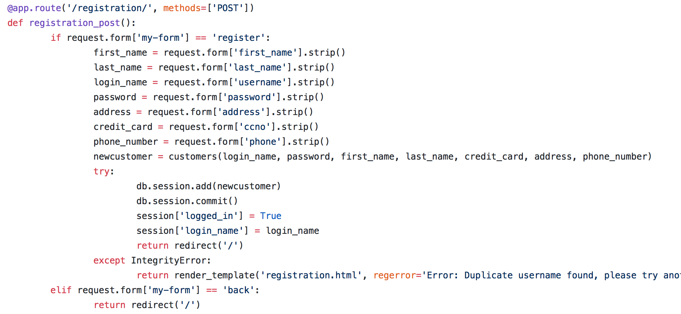

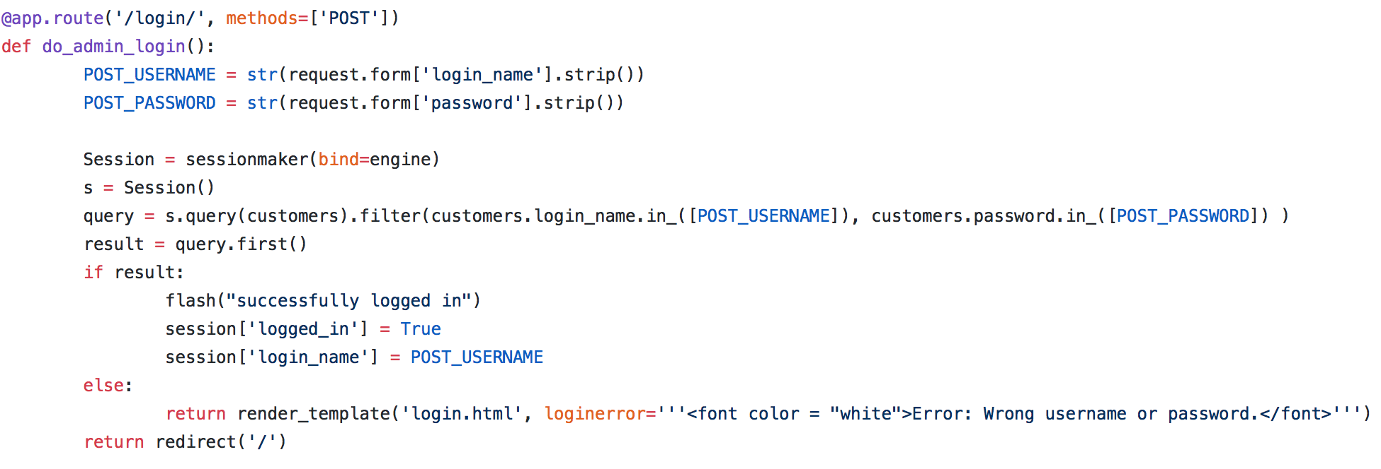

1. After registration, a user can order one or more books. A user may order multiple copies of a book, one or more times.

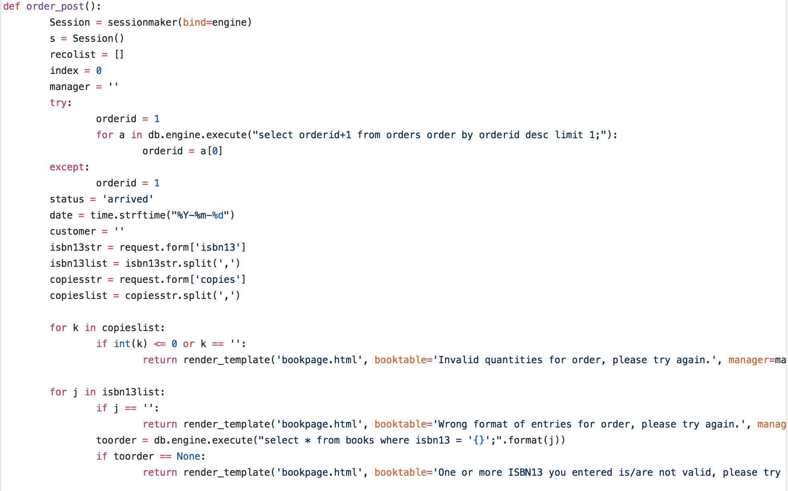

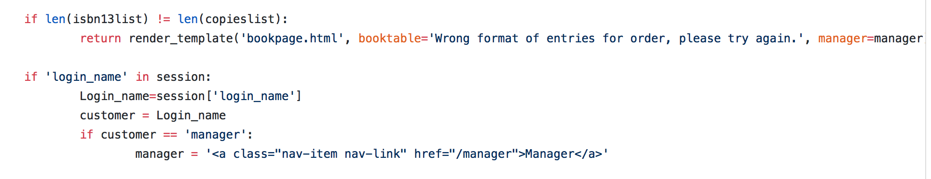

1. User records: Upon user demand, you should print the full record of a user:

• his/her account information

• his/her full history of orders (book name, number of copies, date etc.)

• his/her full history of feedbacks

• the list of all the feedbacks he/she ranked with respect to usefulness

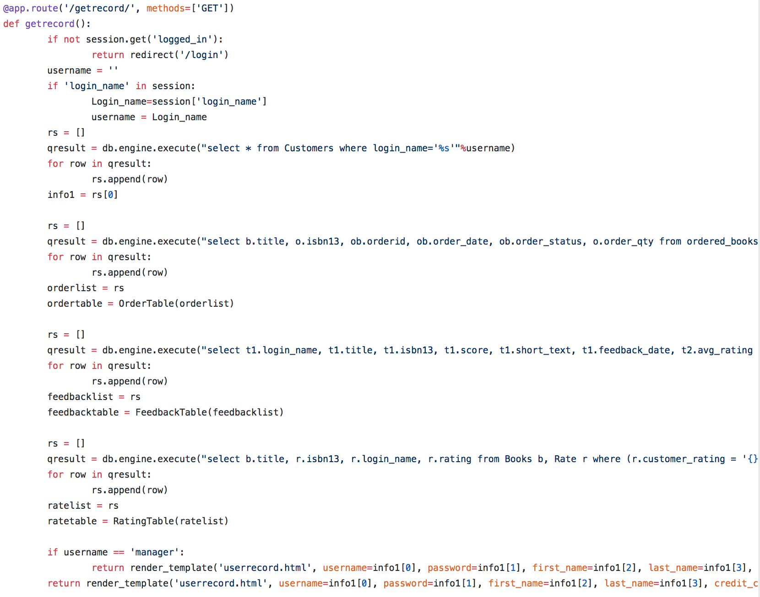

1. New book: The store manager can add new book into the database along with its details.

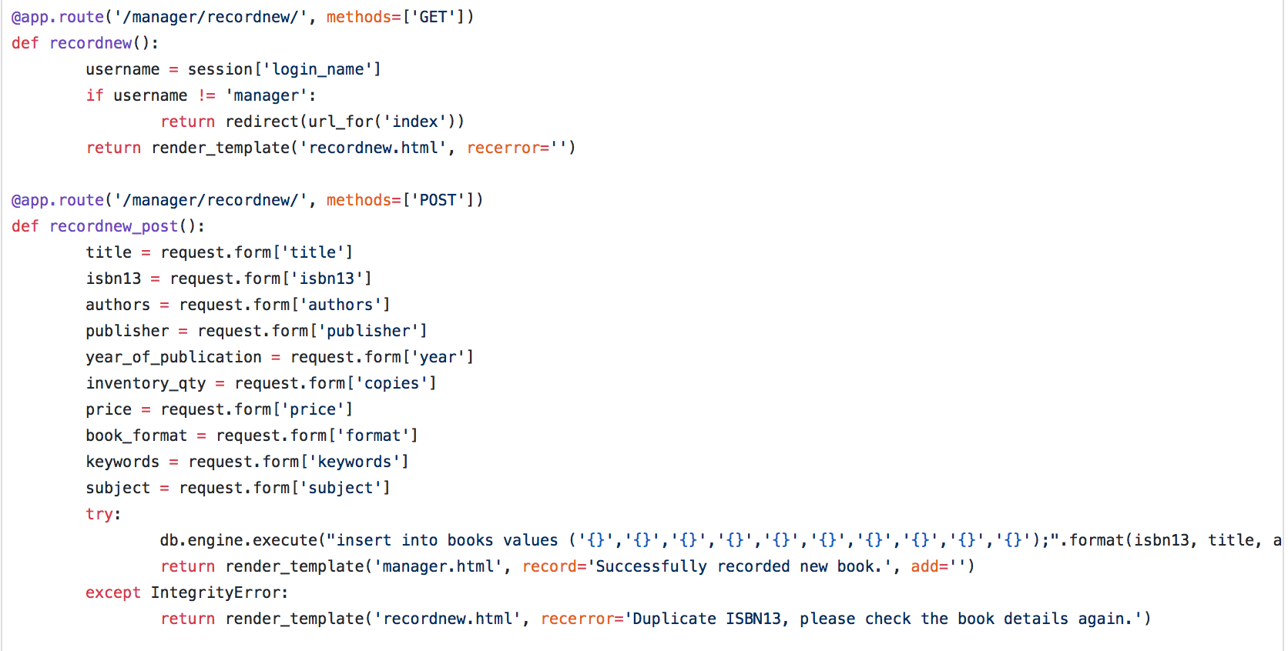

1. The manager can increment the number of books in the library

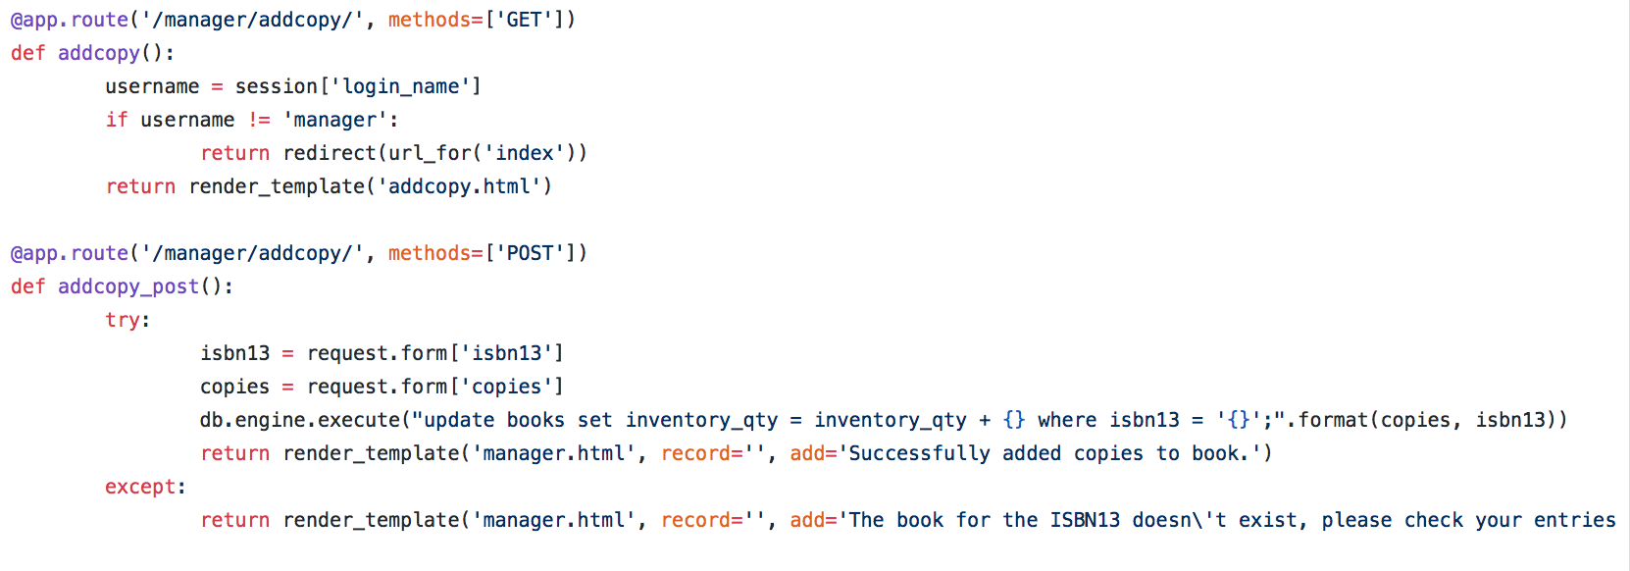

1. Feedback recordings: Users can record their feedback for a book. Details like date, numerical score and comments can be recorded. No changes is allowed and only one feedback per user is allowed.

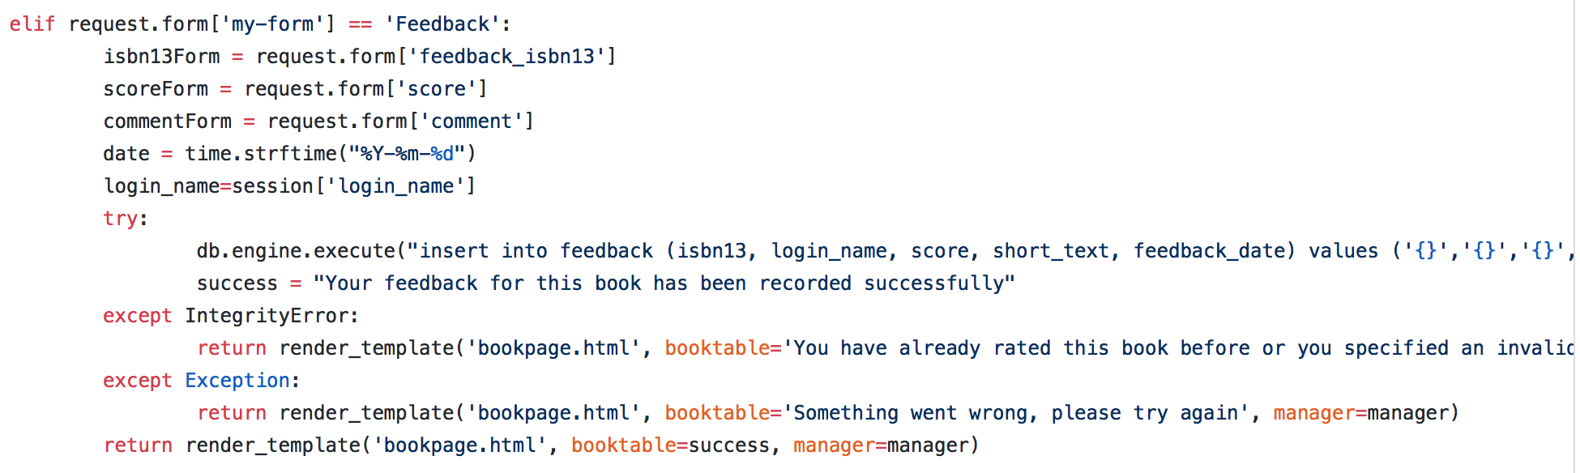

1. Users can rate the usefulness of other’s feedback. Users are not allowed to rate their own feedback, and are not allowed to rate a feedback twice.

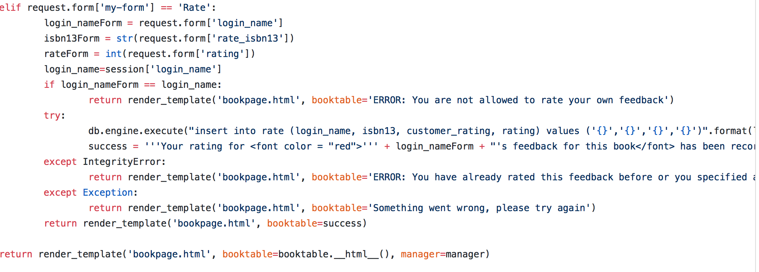

1. User will be able to browse books, and request for which books using conjunctive queries on the authors, and/or publisher, and/or title, and/or subject. Users can also specify results to be sorted by a) year, or b) by the average score of the feedbacks

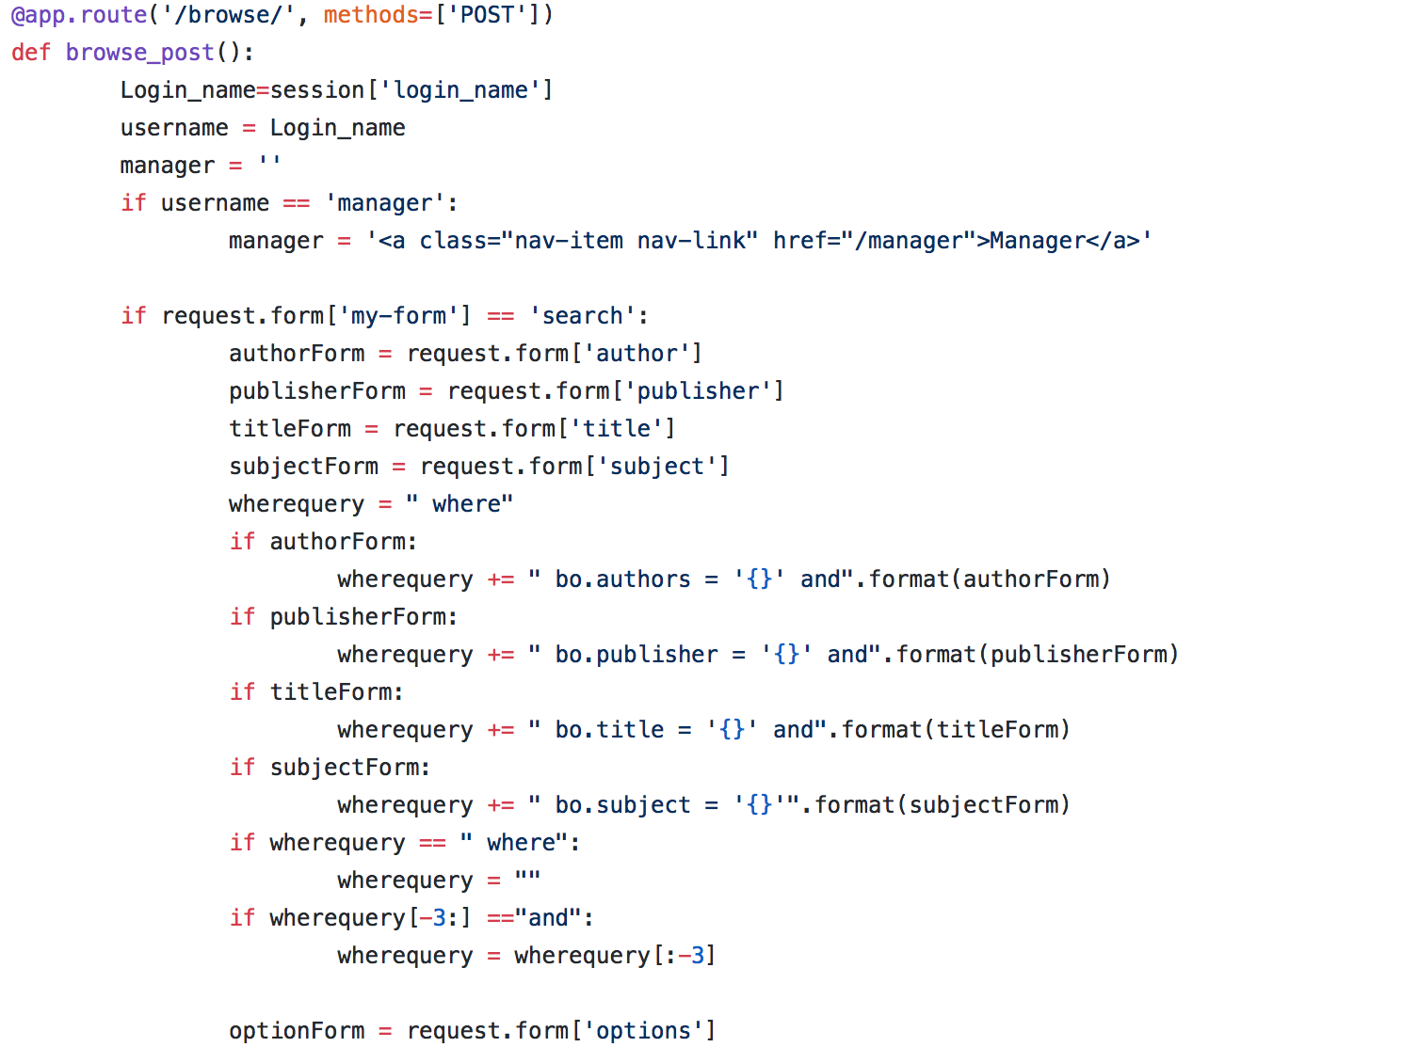

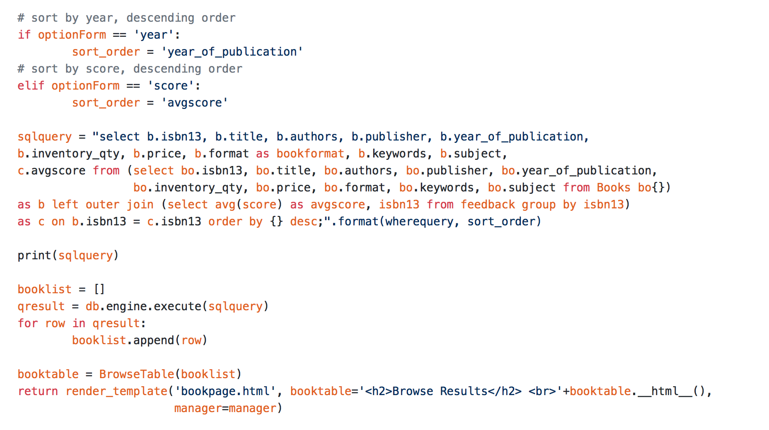

1. For a given book, user can ask for top n most useful feedback. N is specified by the user.

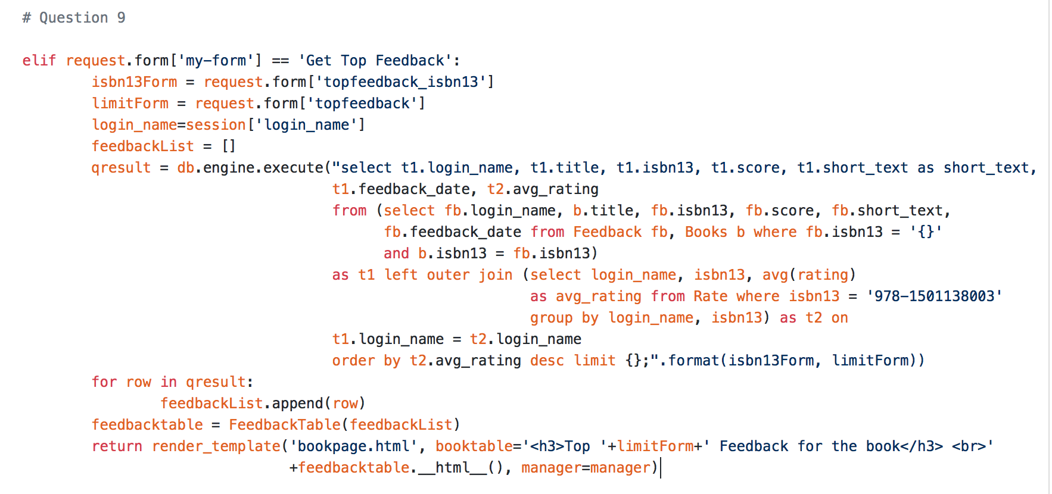

1. Book recommendation – when user orders copy of a book say book A, the website recommends a list of other suggested books. A book B is suggested if there exist a user that have purchased both book A and book B. The suggested books are sorted based on decreasing sales count.

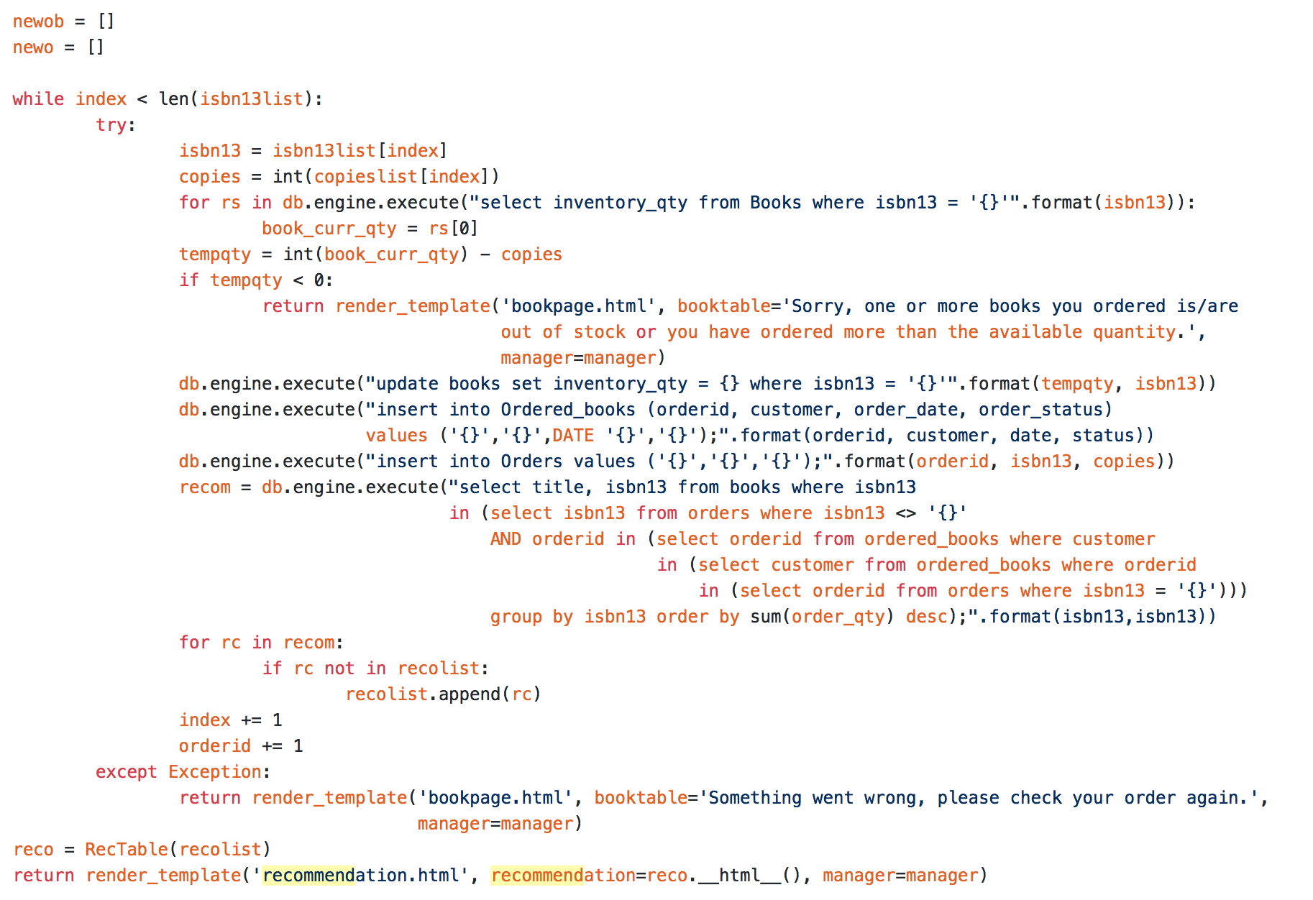

1. Statistics – Every month the store manager wants
   * The list of the m most popular books (copies sold this month)
   * The list of m most popular authors
   * The list of m most popular publishers